SQL Assignment

1. Employee Table

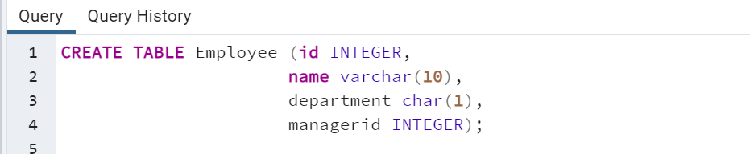

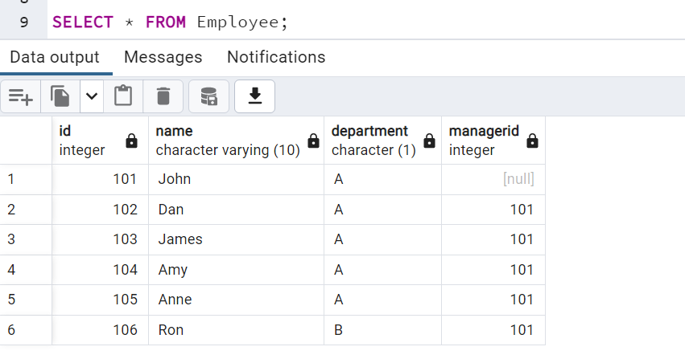

SELECT Name

FROM Employee

WHERE id =

(SELECT managerid

FROM Employee

GROUP BY ManagerId

HAVING COUNT(ManagerId) >=5

);

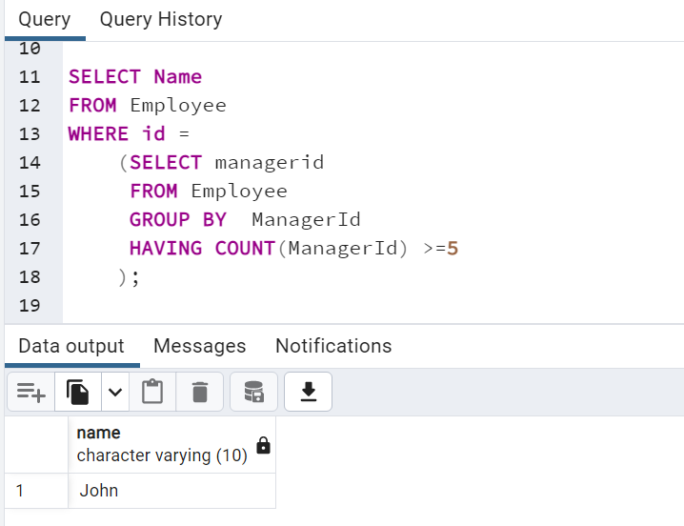

2. Employee Table

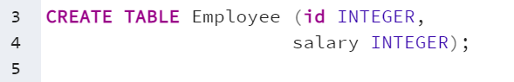

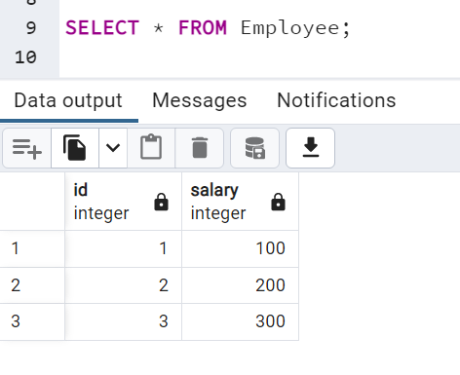

CREATE FUNCTION getNthHighestSalary(N INT) RETURNS INT

BEGIN

DECLARE M INT;

SET M = N - 1;

RETURN (

SELECT DISTINCT Salary FROM Employee ORDER BY Salary DESC LIMIT M, 1

);

END

3. Table RequestAccepted

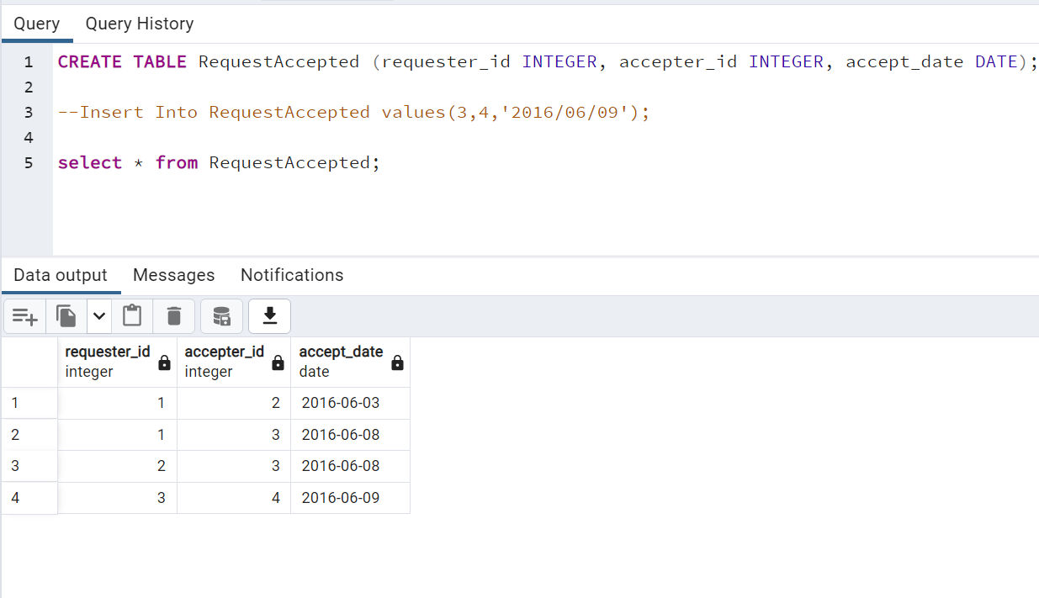SELECT id, COUNT(*) AS num

FROM (

SELECT requester_id AS id FROM requestaccepted

UNION ALL

SELECT accepter_id FROM requestaccepted

) AS friends_count

GROUP BY id

ORDER BY num DESC LIMIT 1;

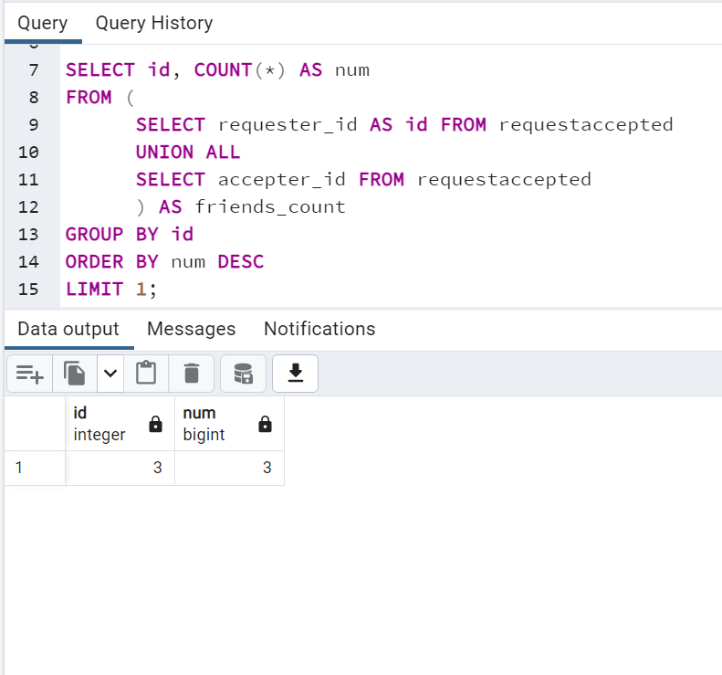

4. Table SEAT

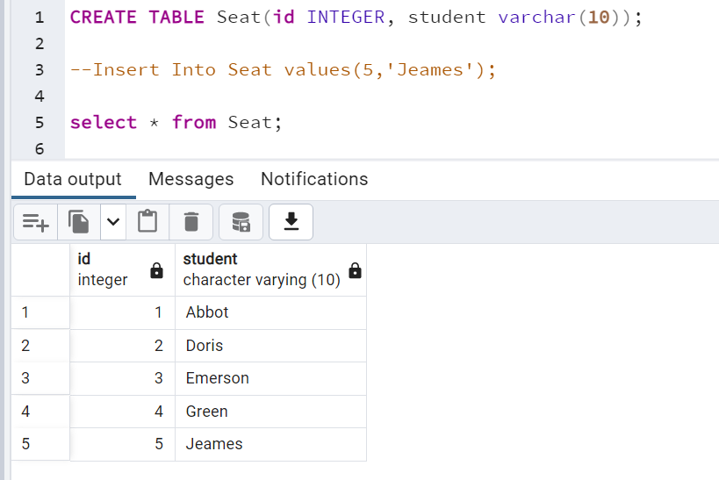 SELECT

(CASE

WHEN MOD(id, 2) != 0 AND counts != id THEN id + 1

WHEN MOD(id, 2) != 0 AND counts = id THEN id

ELSE id - 1

END

) AS id, student

FROM seat, (SELECT COUNT(*) AS counts FROM seat) AS seat_counts

ORDER BY id ASC;

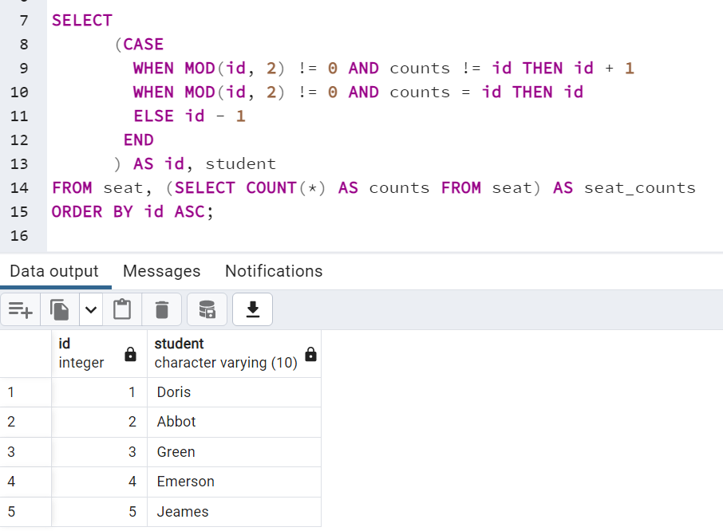

5. Table Customer

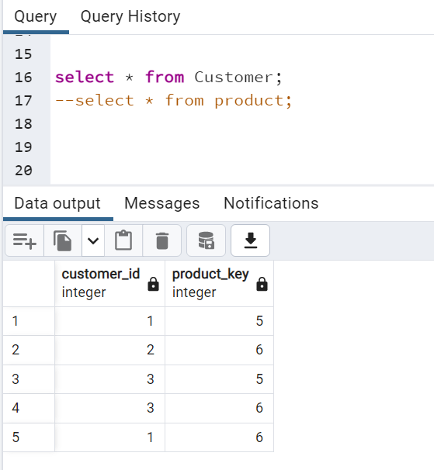

Table Product

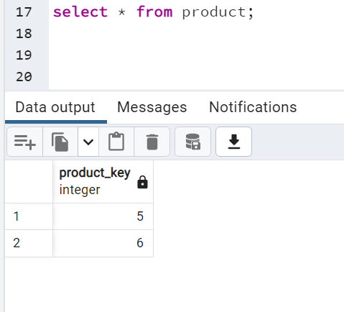

SELECT customer_id

FROM customer

GROUP BY customer_id

HAVING COUNT( DISTINCT product_key) = (SELECT COUNT(*) FROM product)

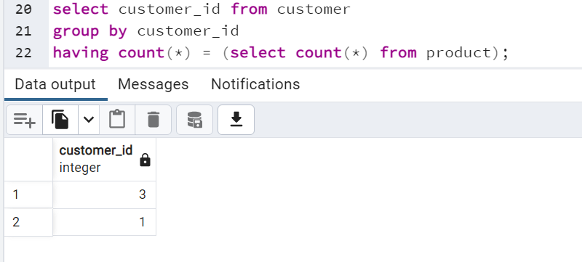

6. Table Users

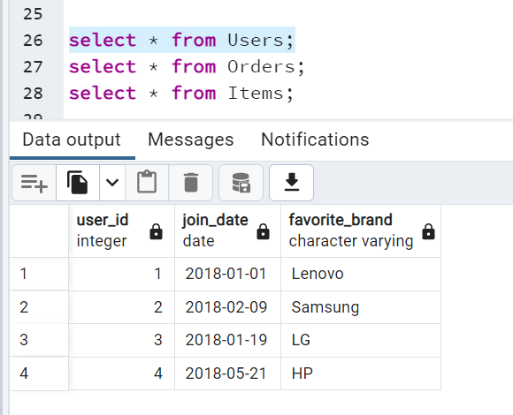

Table Orders

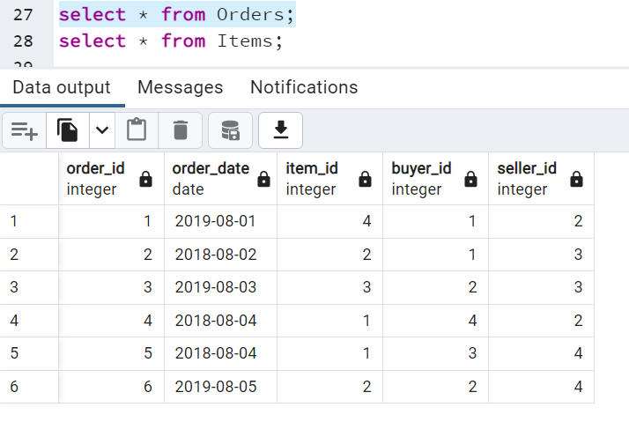

Table Items

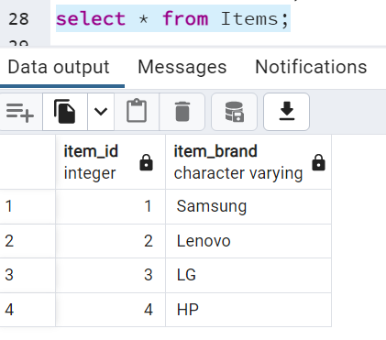

SELECT U.user_id AS buyer_id, U.join_date,

SUM(CASE WHEN extract(YEAR from O.order_date) = '2019' THEN 1 ELSE 0 END) AS orders_in_2019

FROM Users U

LEFT JOIN Orders O

ON U.user_id = O.buyer_id

GROUP BY U.user_id,U.join_date

ORDER BY U.user_id;

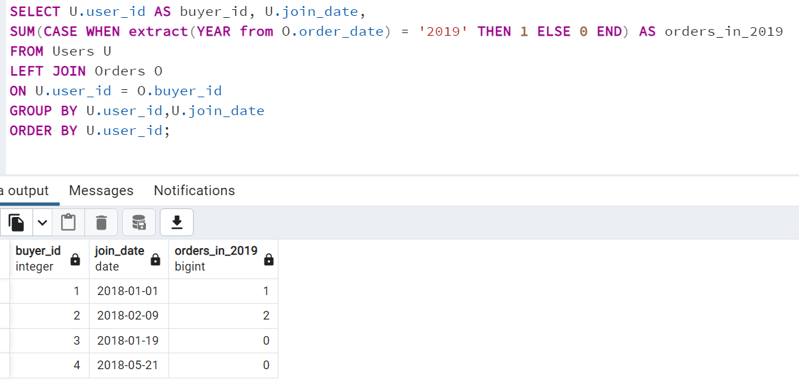

7. Table Traffic

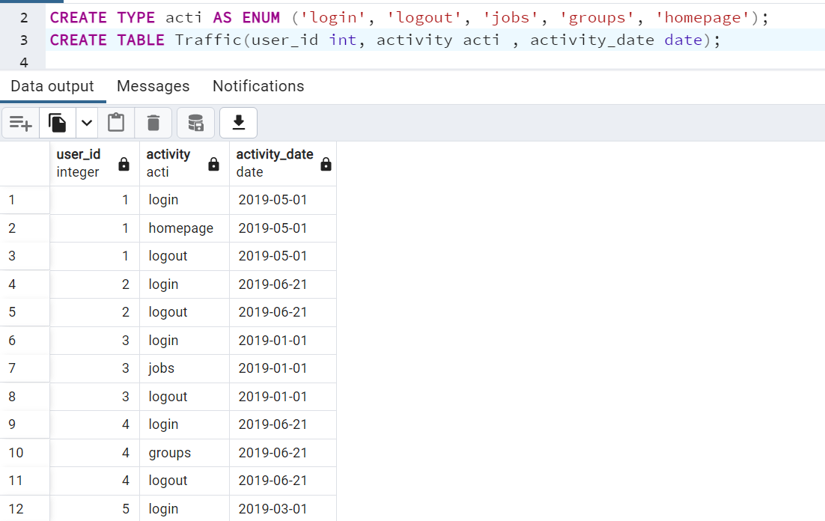

SELECT login_date, COUNT(user_id) AS user_count

FROM

(SELECT user_id, MIN(activity_date) AS login_date

FROM Traffic

WHERE activity='login'

GROUP BY user_id) AS t

WHERE ('2019-06-30'::date-login_date::date) <= 90

GROUP BY login_date

ORDER BY login_date

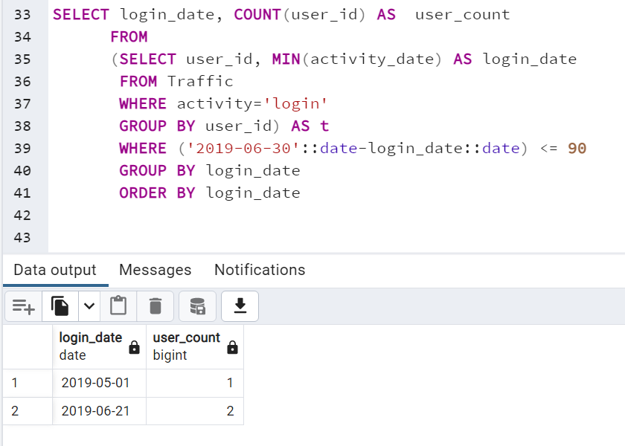

8. Table Products

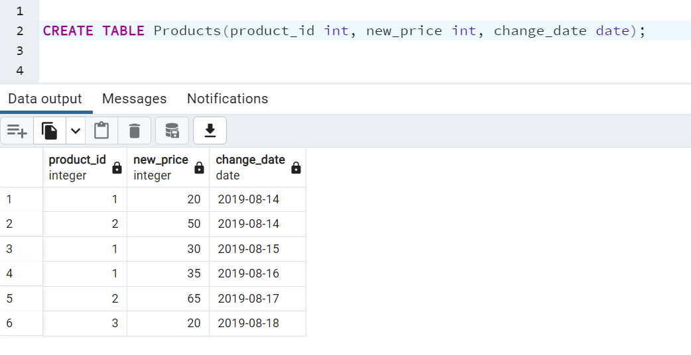

select * from (

select product_id, new_price as price from Products

where (product_id, change_date) in (

select product_id, max(change_date) from Products

where change_date <= '2019-08-16'

group by product_id

)

union

select distinct product_id, 10 as price from Products

where product_id not in (

select product_id from Products

where change_date <= '2019-08-16'

)

) union_result;

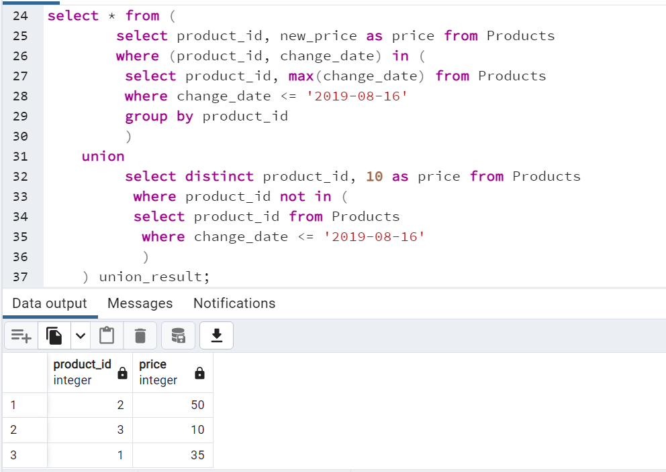

9. Table Transactions

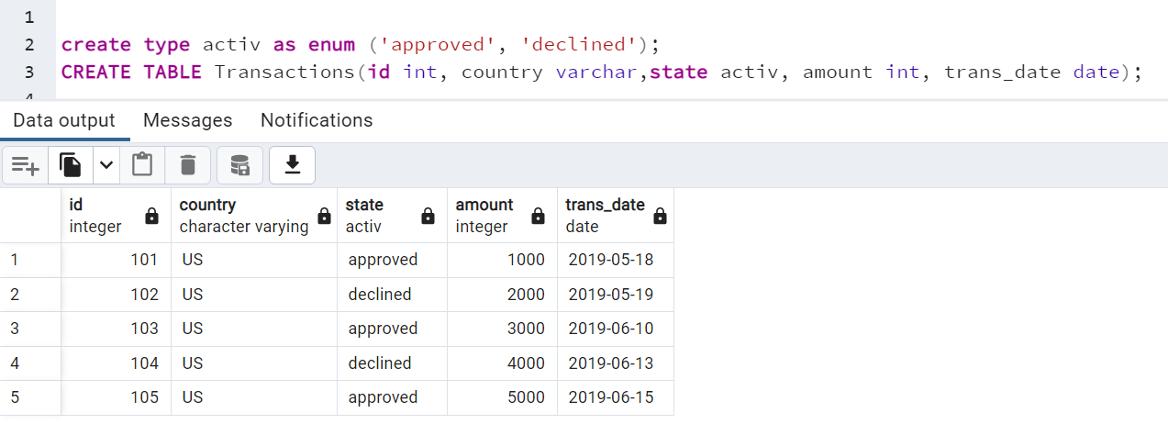

Table Chargebacks

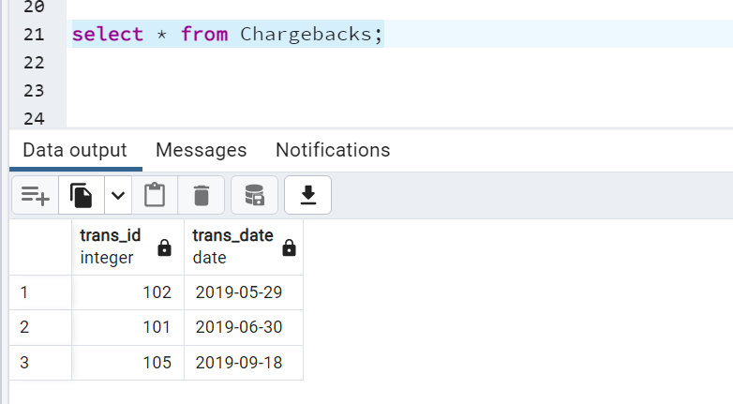

select

month

,country

,sum(case when state = 'approved' then 1 else 0 end) as approved_count

,sum(case when state = 'approved' then amount else 0 end) as approved_amount

,sum(case when state = 'chargeback' then 1 else 0 end) as chargeback_count

,sum(case when state = 'chargeback' then amount else 0 end) as chargeback_amount

from ((

select

TO_CHAR(trans_date, 'YYYY-MM') as month

,country

,amount

,'approved' as state

from Transactions

where state = 'approved'

)

union all

(select TO_CHAR(Chargebacks.trans_date, 'YYYY-MM') as month,

country,

amount,

'chargeback' as state

from Transactions

inner join Chargebacks

on Transactions.id = Chargebacks.trans_id

)) temp

group by temp.month, temp.country

order by month;

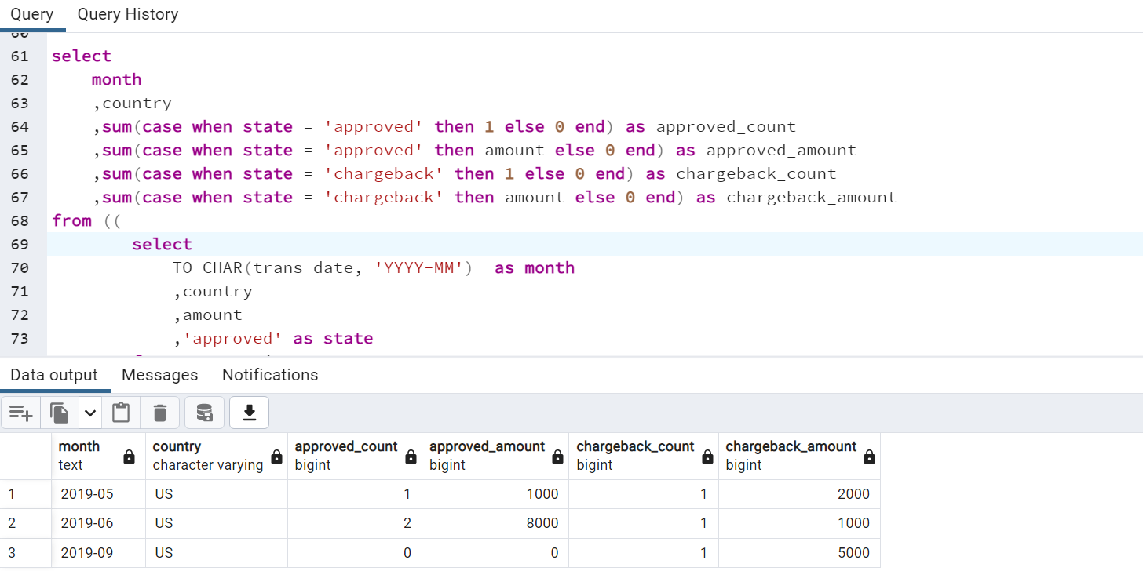

10. Table Teams

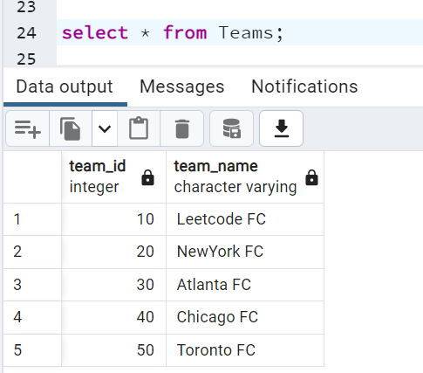

Table Matches

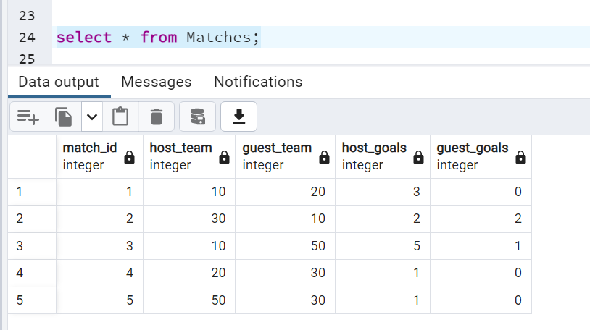

select t.team_id, t.team_name,

sum(case when t.team_id = m.host_team and m.host_goals > m.guest_goals then 3

when t.team_id = m.host_team and m.host_goals = m.guest_goals then 1

when t.team_id = m.guest_team and m.host_goals < m.guest_goals then 3

when t.team_id = m.guest_team and m.host_goals = m.guest_goals then 1

else 0 end) as num_points

from Matches m

right join Teams t

on m.host_team = t.team_id or m.guest_team = t.team_id

group by team_id, team_name

order by num_points desc, team_id

